**Transaction Recovery**

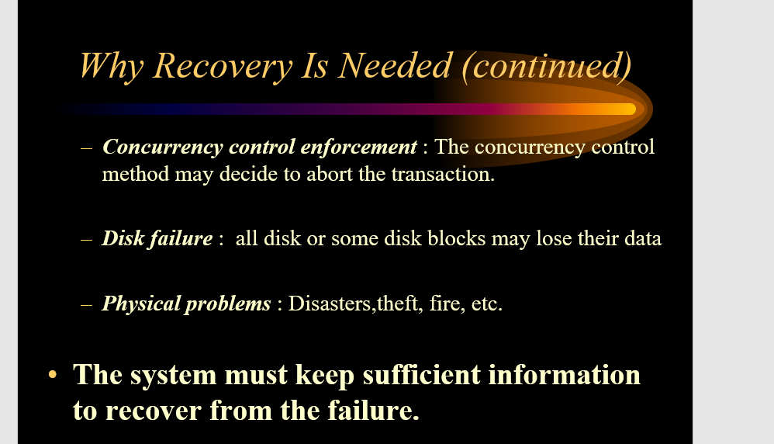  
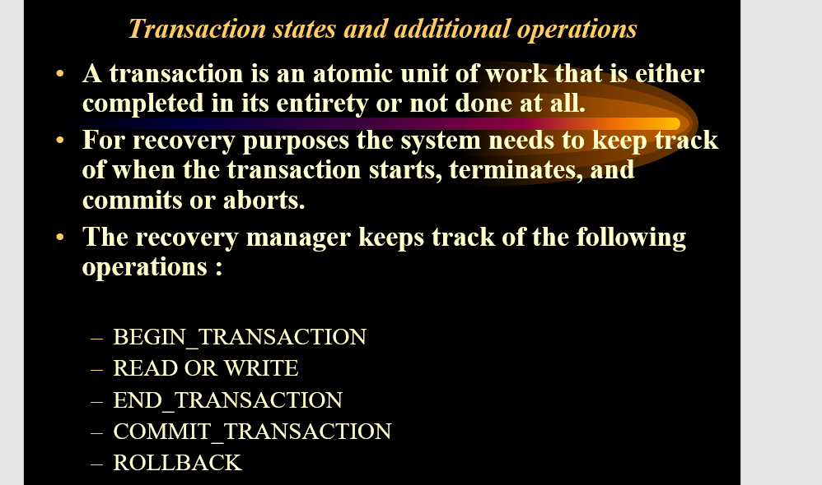

**Transaction states in DBMS**

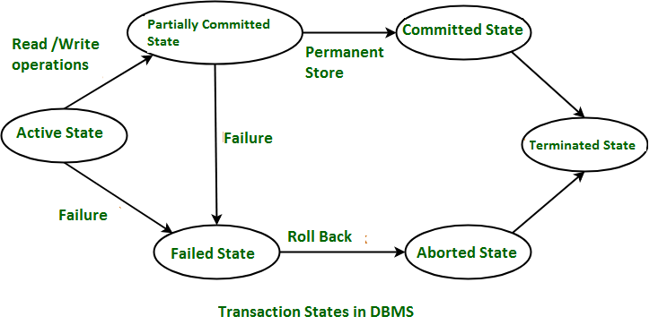  
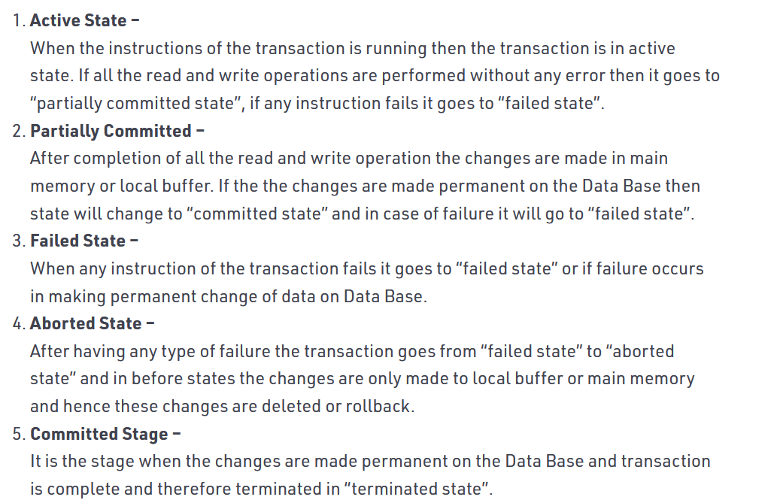  
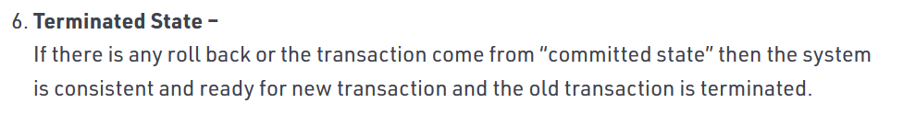

**The System Logs**

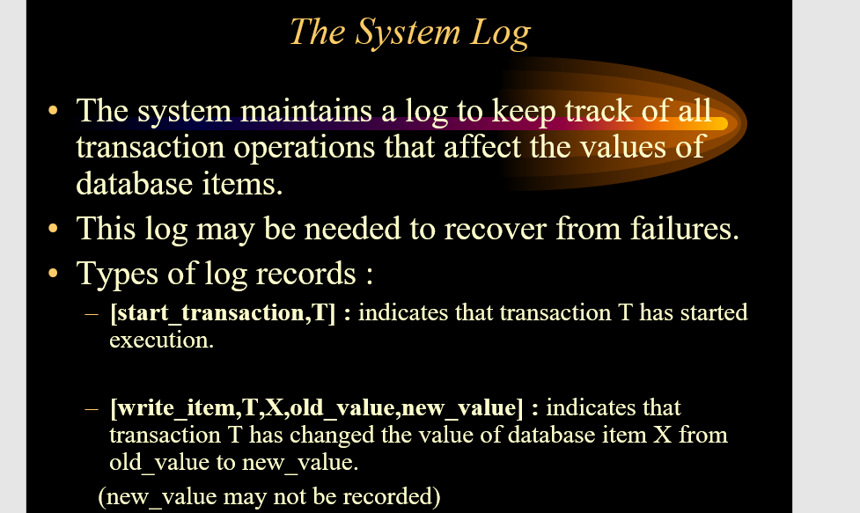  
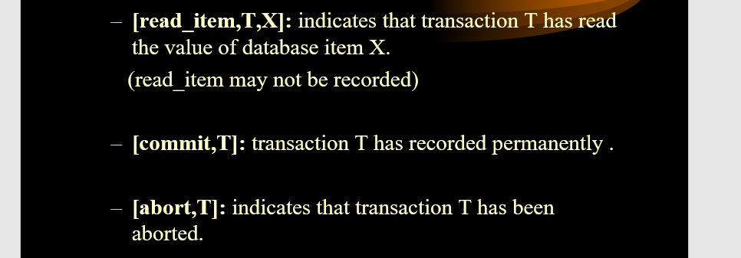

**ACID Properties**

**Schedules of Transaction**

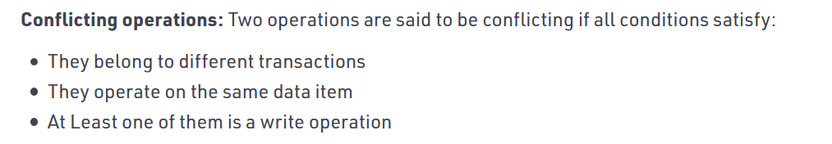

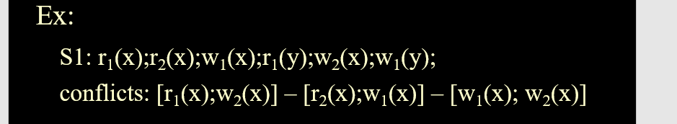

This is a conflict since two operations occurs on the same data-item

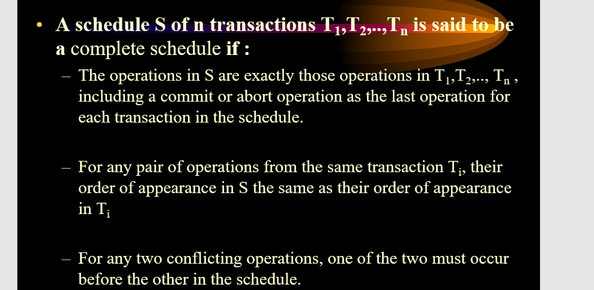

**Types of Scheduler**

1. **Recoverability 2) Serializability**

**Recoverability**

1. Recoverable Scheduler and Ir-recoverable Scheduler
2. Cascading Abort and Cascade-less Schedule
3. Strict schedule

**Recoverability**

**Recoverable Schedules**

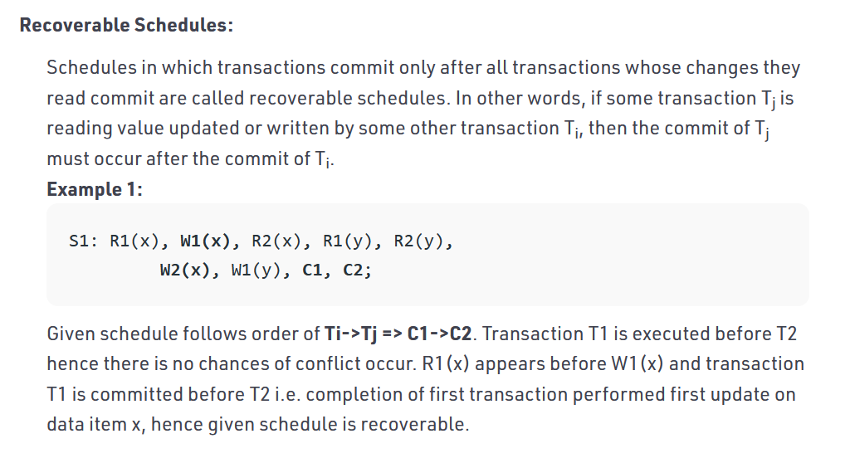

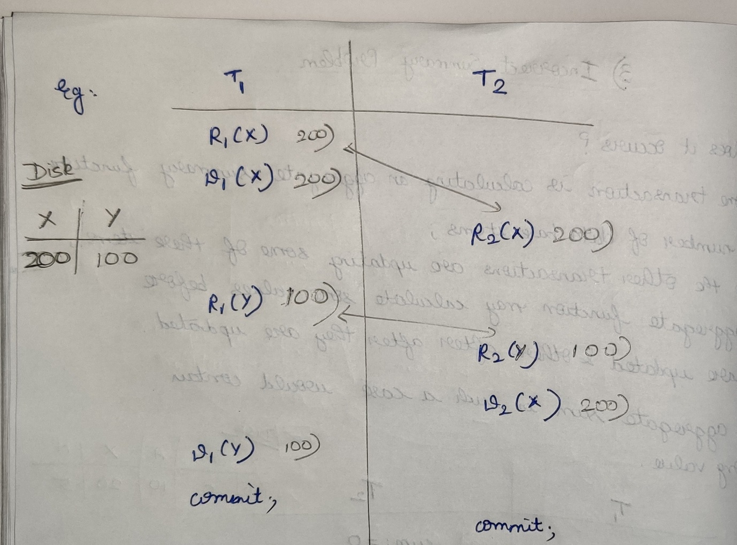

**Ir-recoverable Schedules**

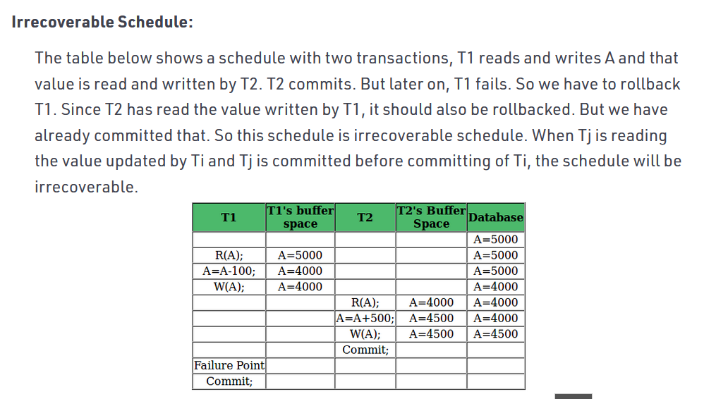

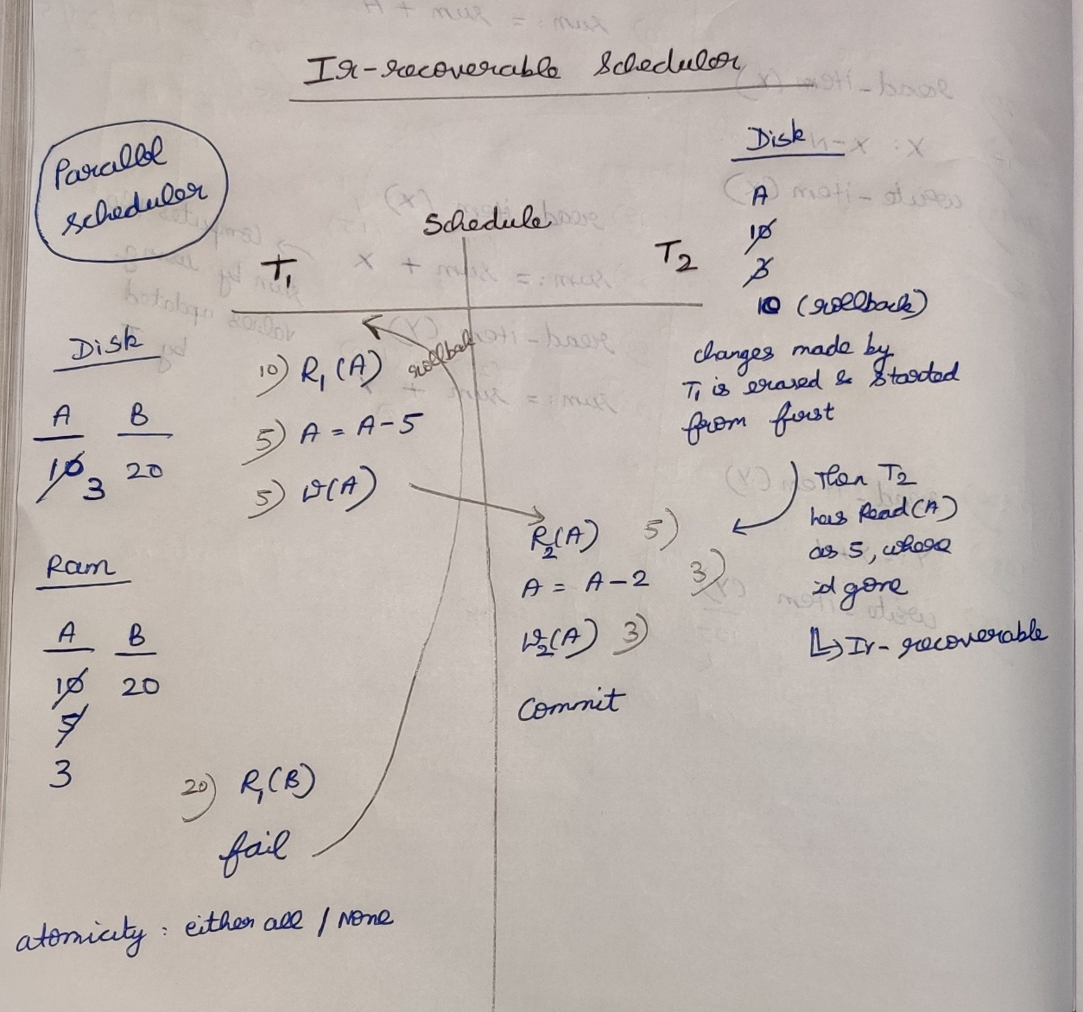

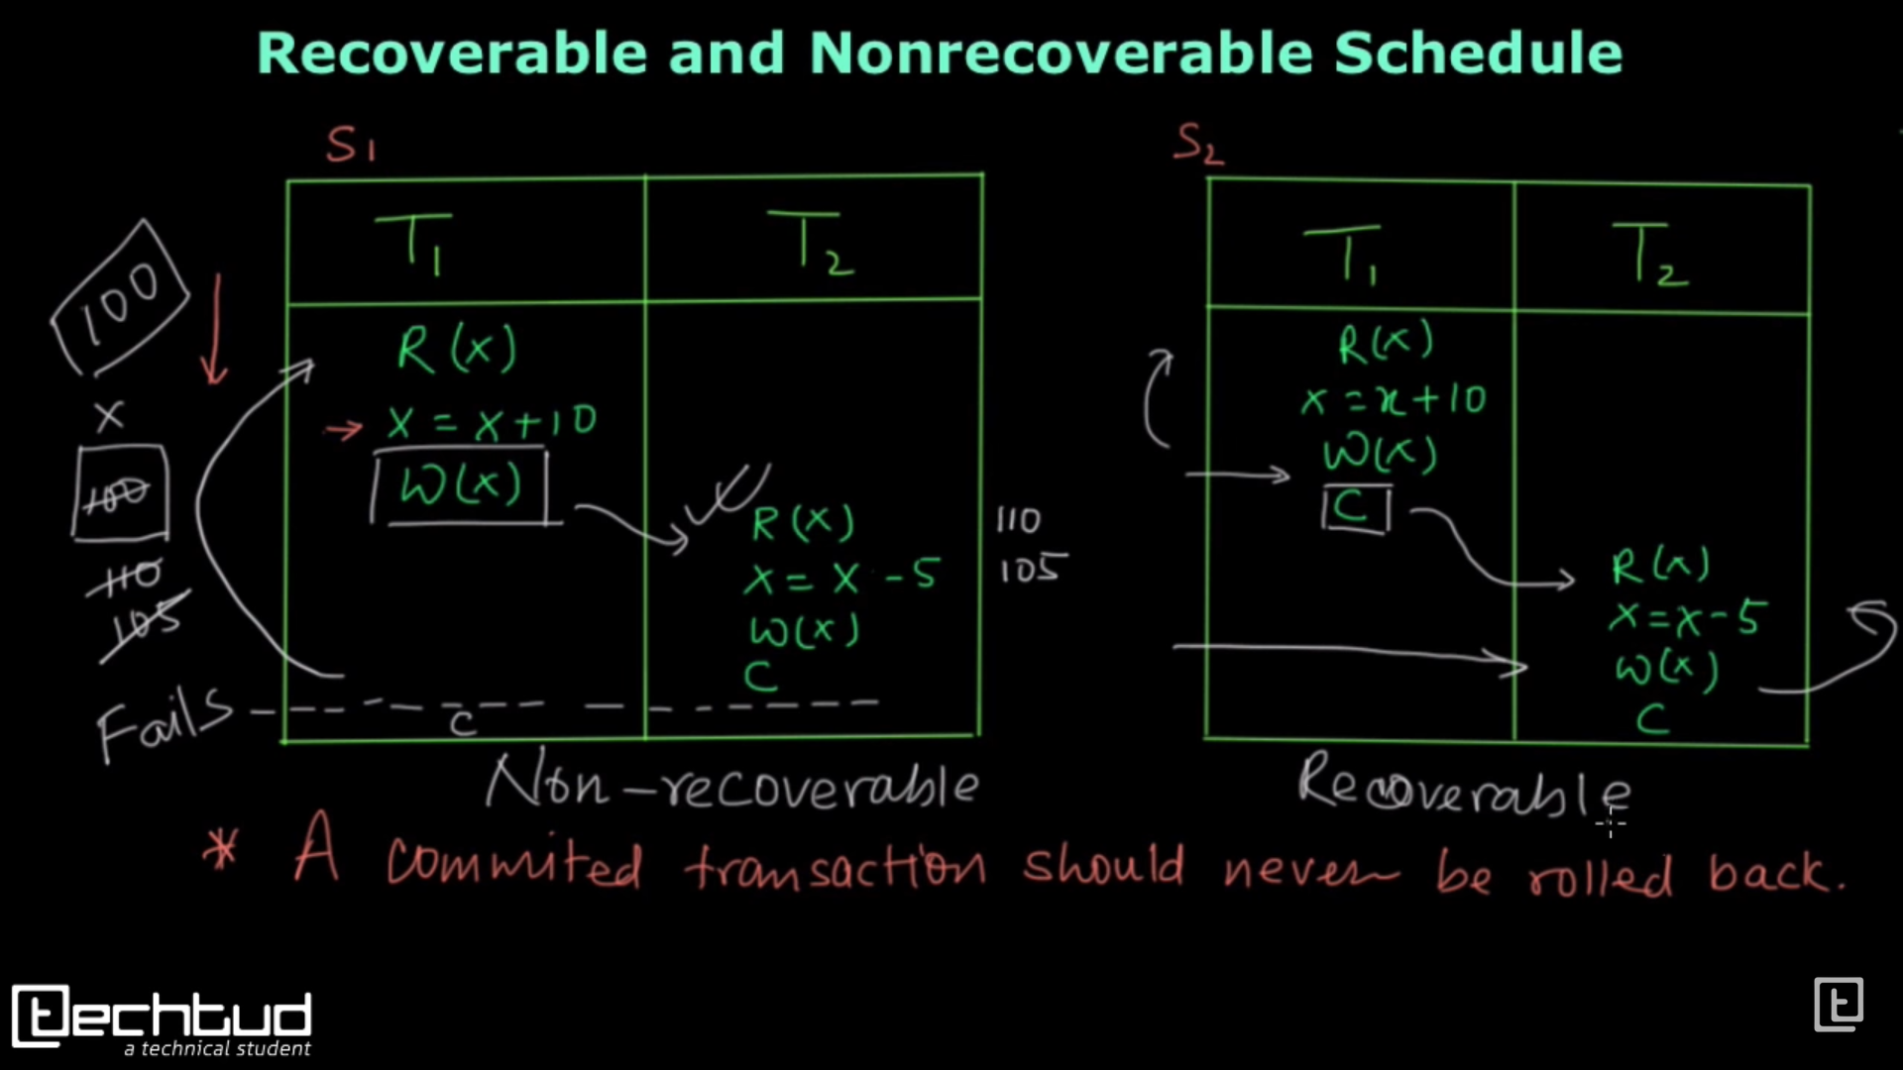

**Non-Recoverable:**  
If any failure happens in T1, then it will rollback so X’s value 🡪 100, but in T2 Read(X) 🡪 110 which lead to data-inconsistent.

**Recoverable:**If any failure happens in T1, then it will roll-back until that T2 will not start its operation.  
If any failure happens in T2, then it will roll-back to T2 itself so there is no effect in T1.

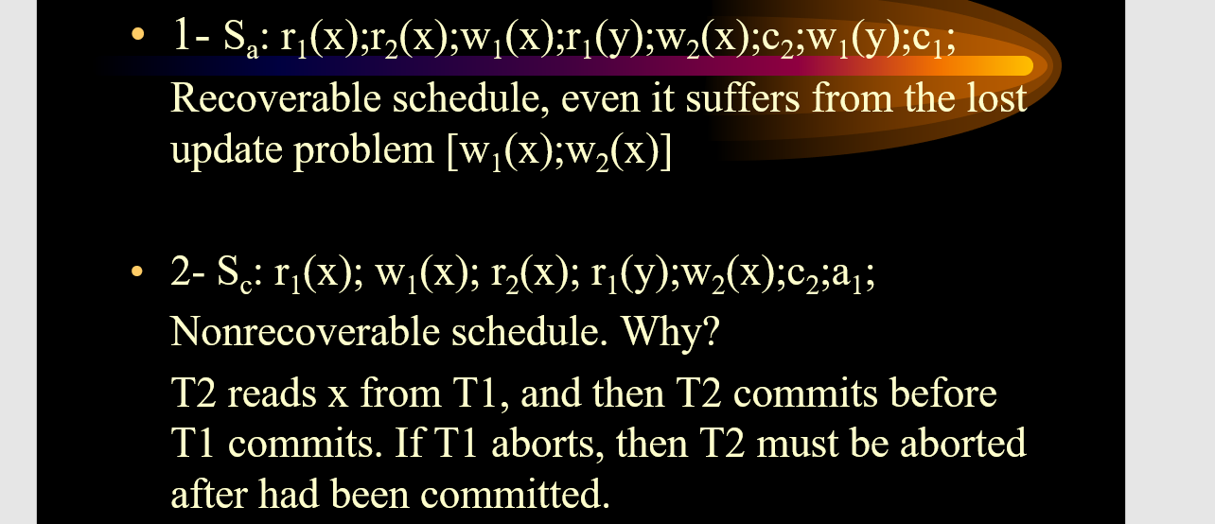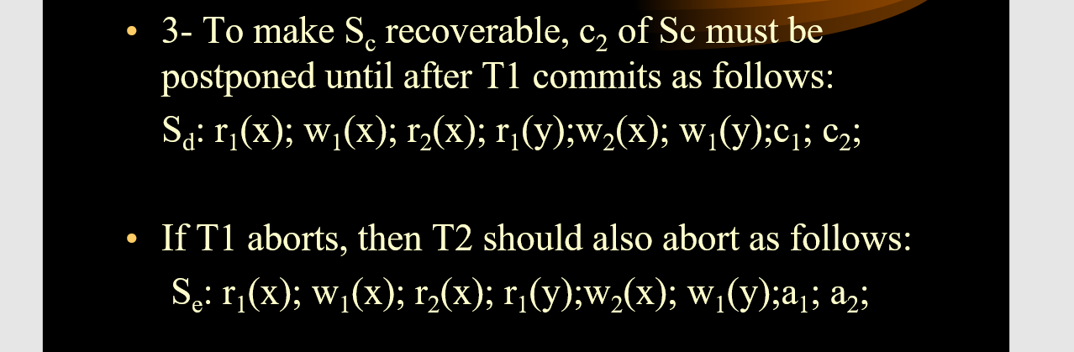

**Cascading Abort**

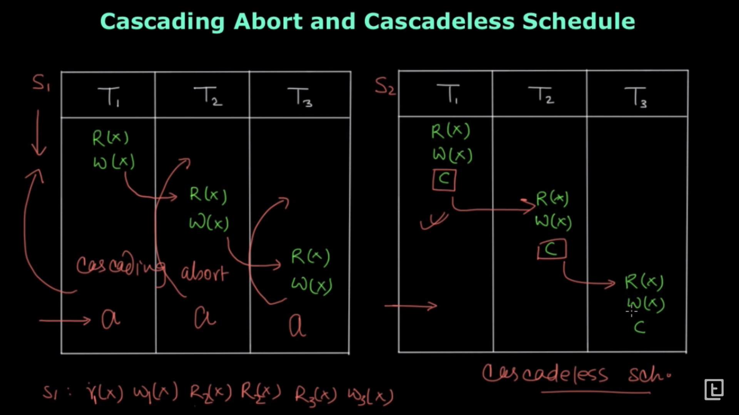

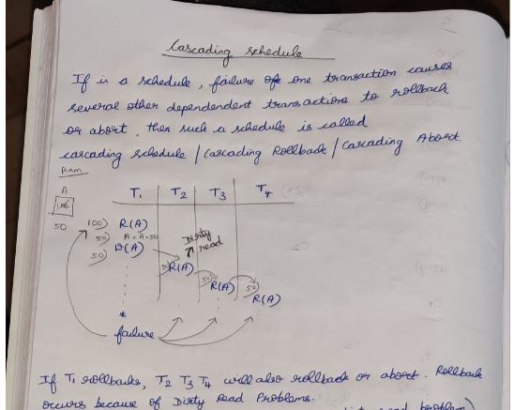

**Cascade less Schedules *(Read is allowed only after committing)***

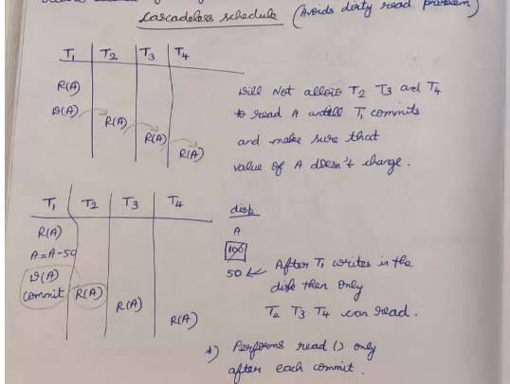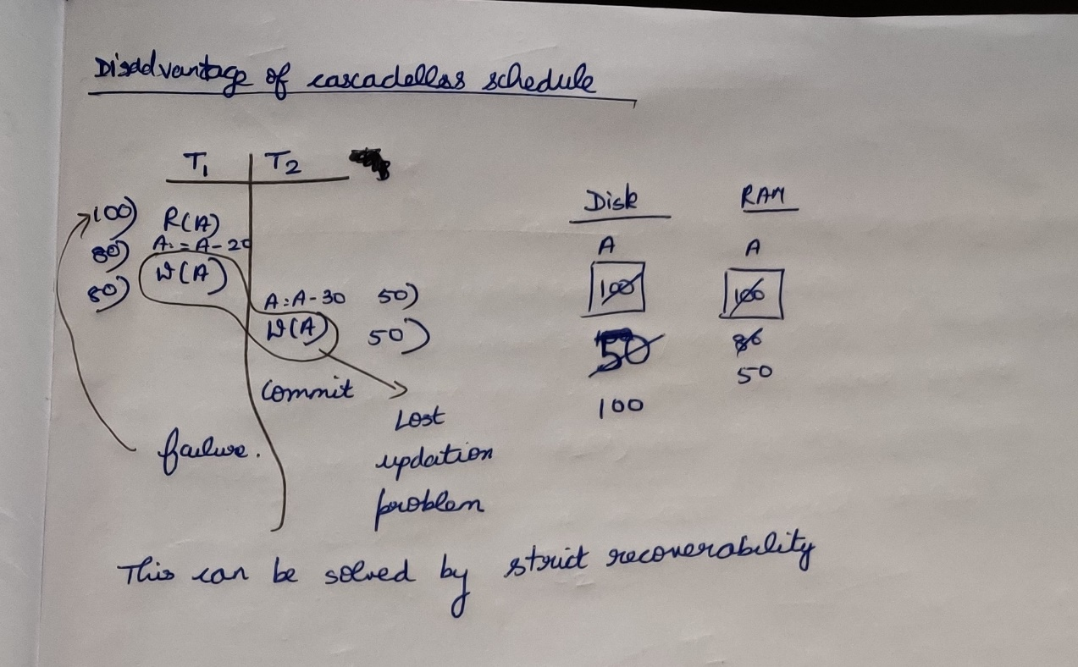

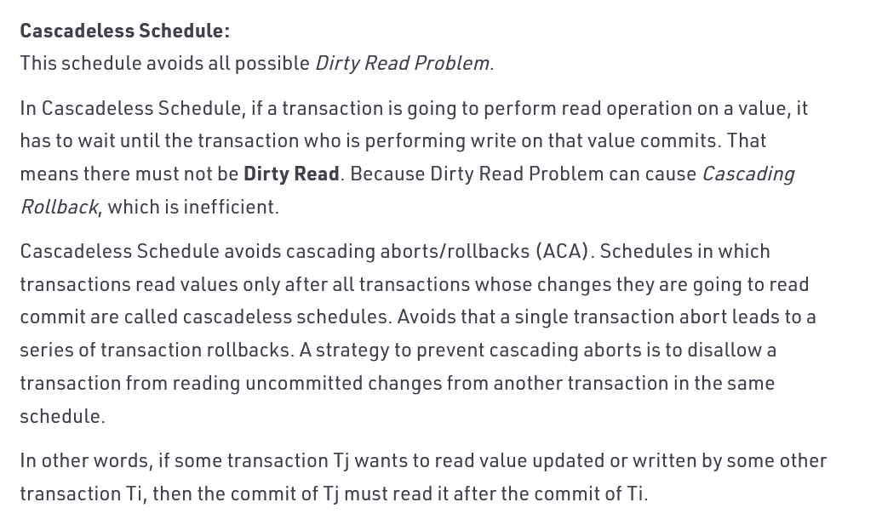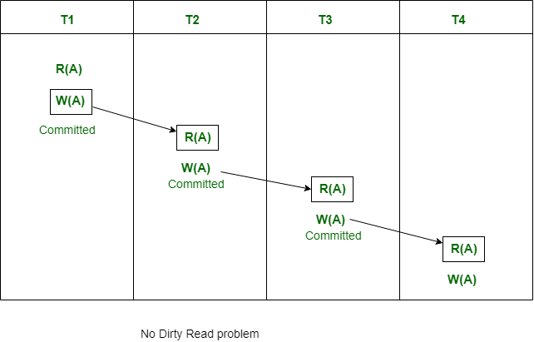

**Strict Schedule**

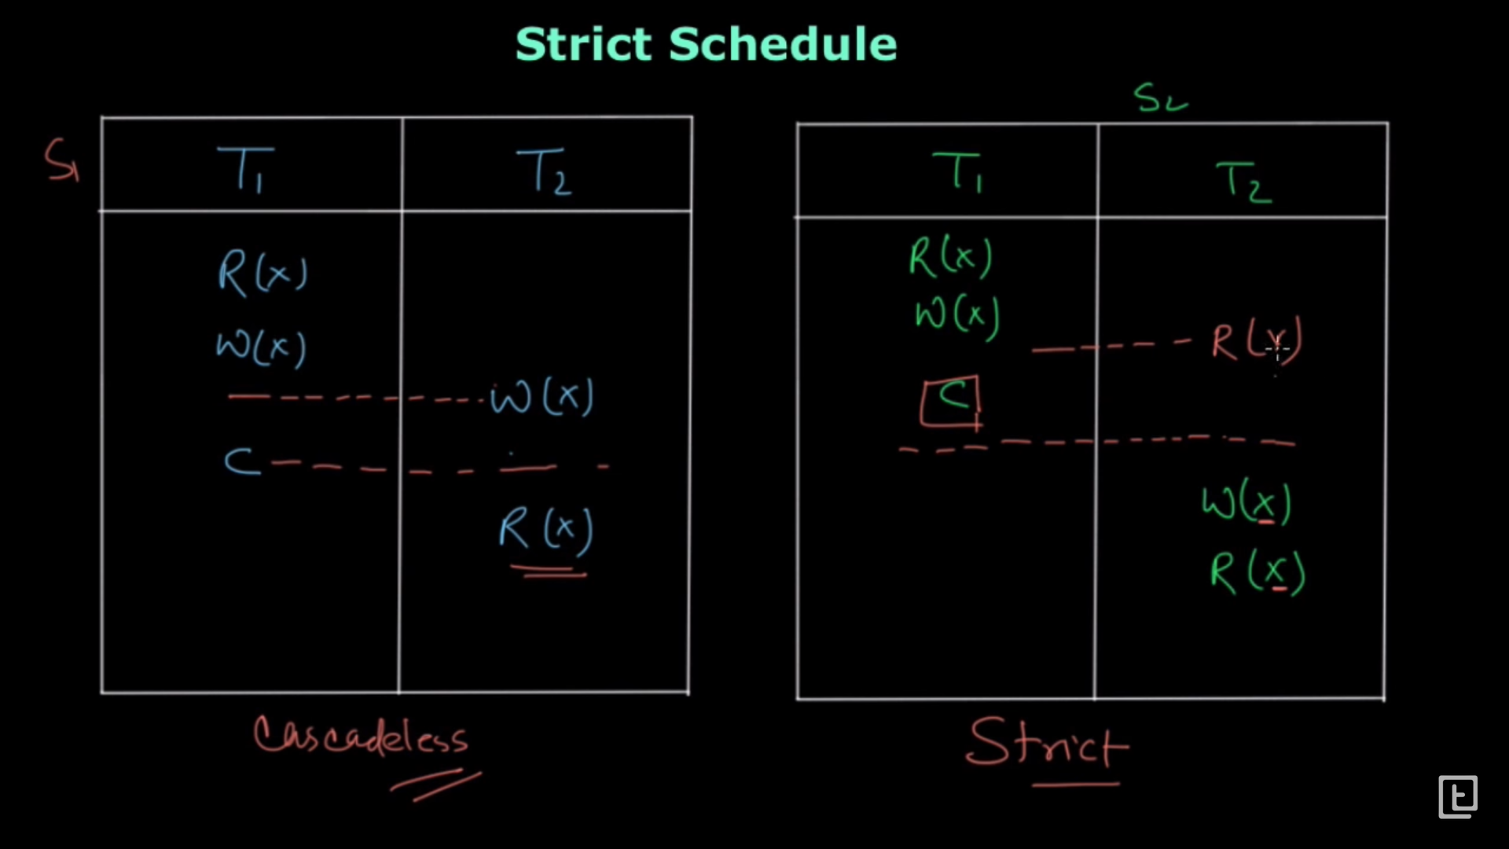

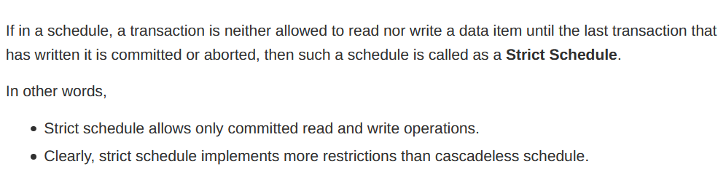

Single data-item (X) 🡪 strict schedule can also become serial scheduler  
Multiple data-item (X,Y,…) 🡪 strict schedule is not serial scheduler

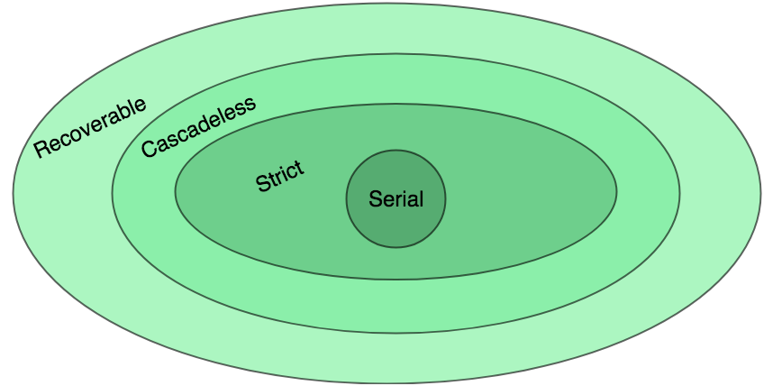

**Serializability 🡪 Conflict serializability   
 🡪 View serializability**

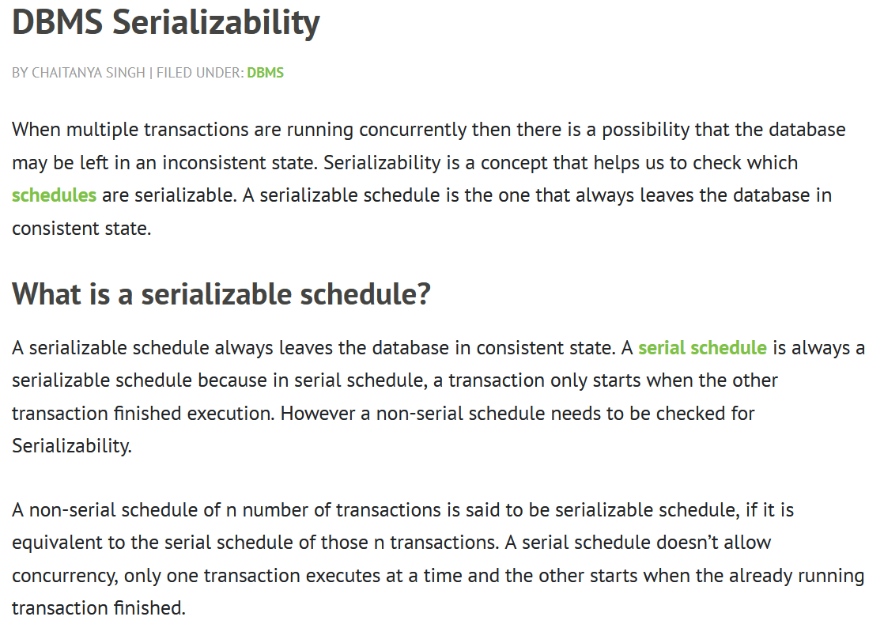

**Conflict Equivalent**

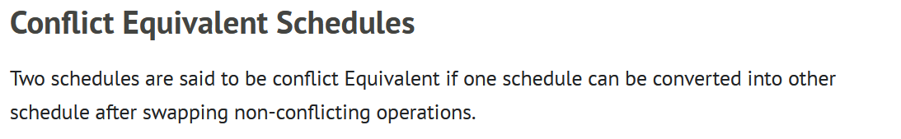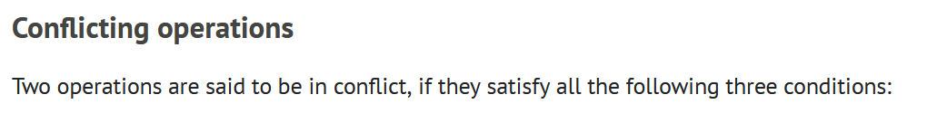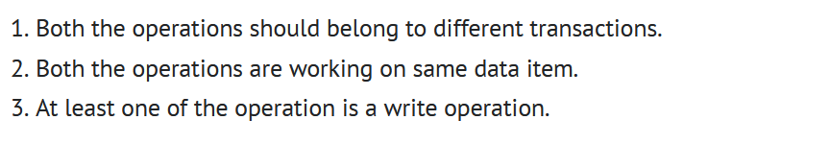

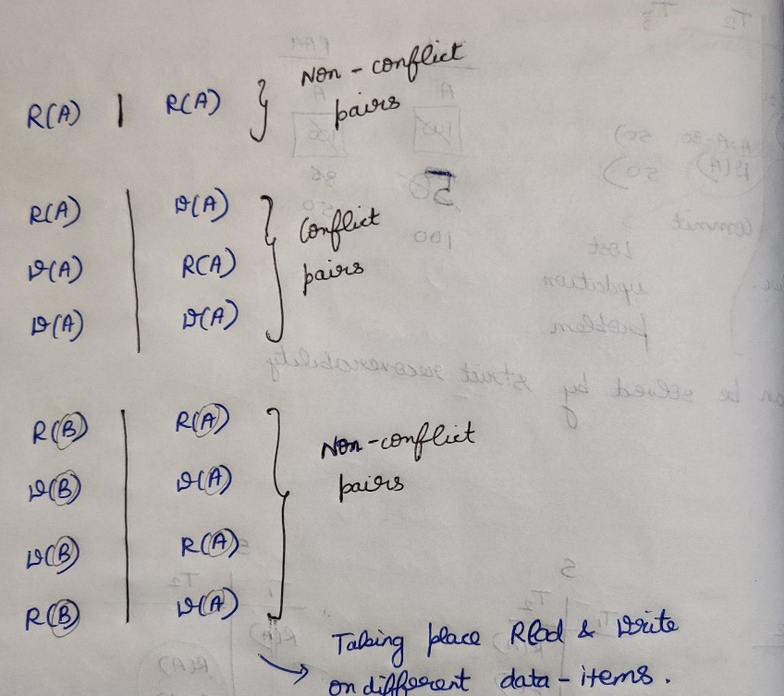

***Adjacent pairs 🡪 Non-conflicting (Change)  
Adjacent pairs 🡪 Conflicting (Don’t Change)***

**If S is conflict equivalent to S’, then S is serializable**

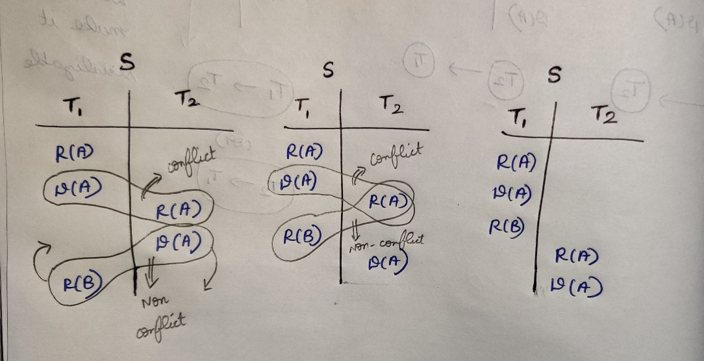

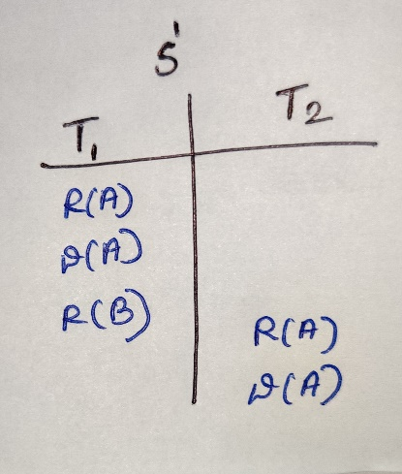

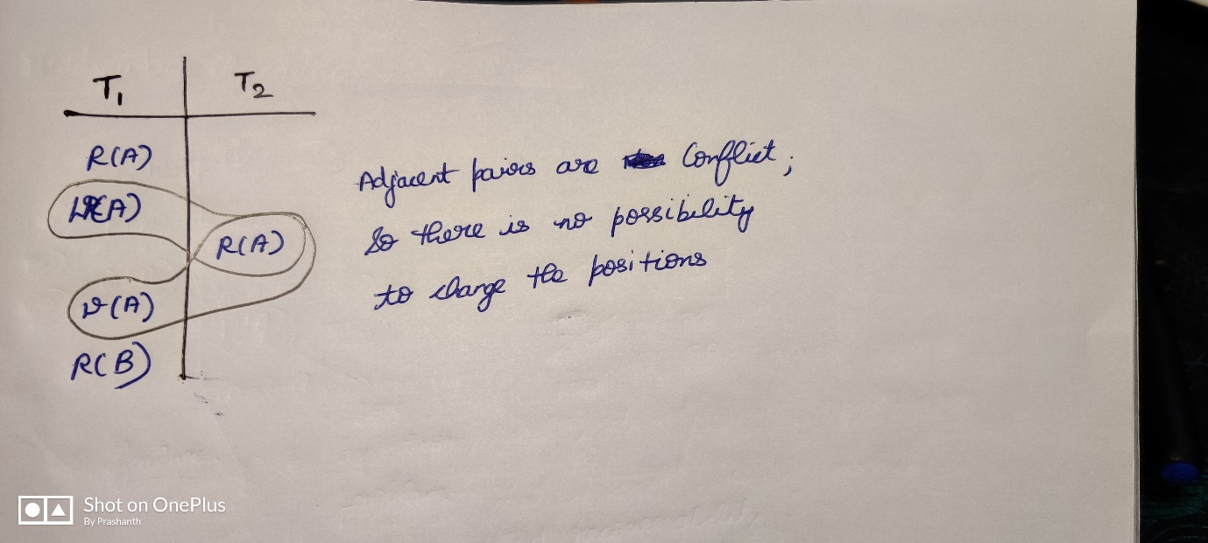

**Conflict serializability**

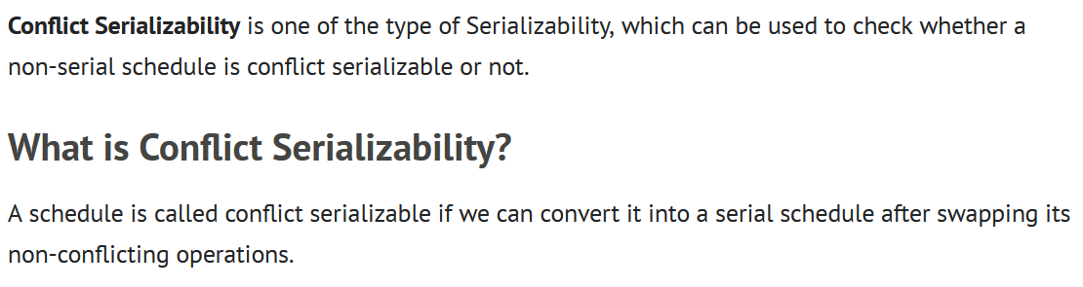

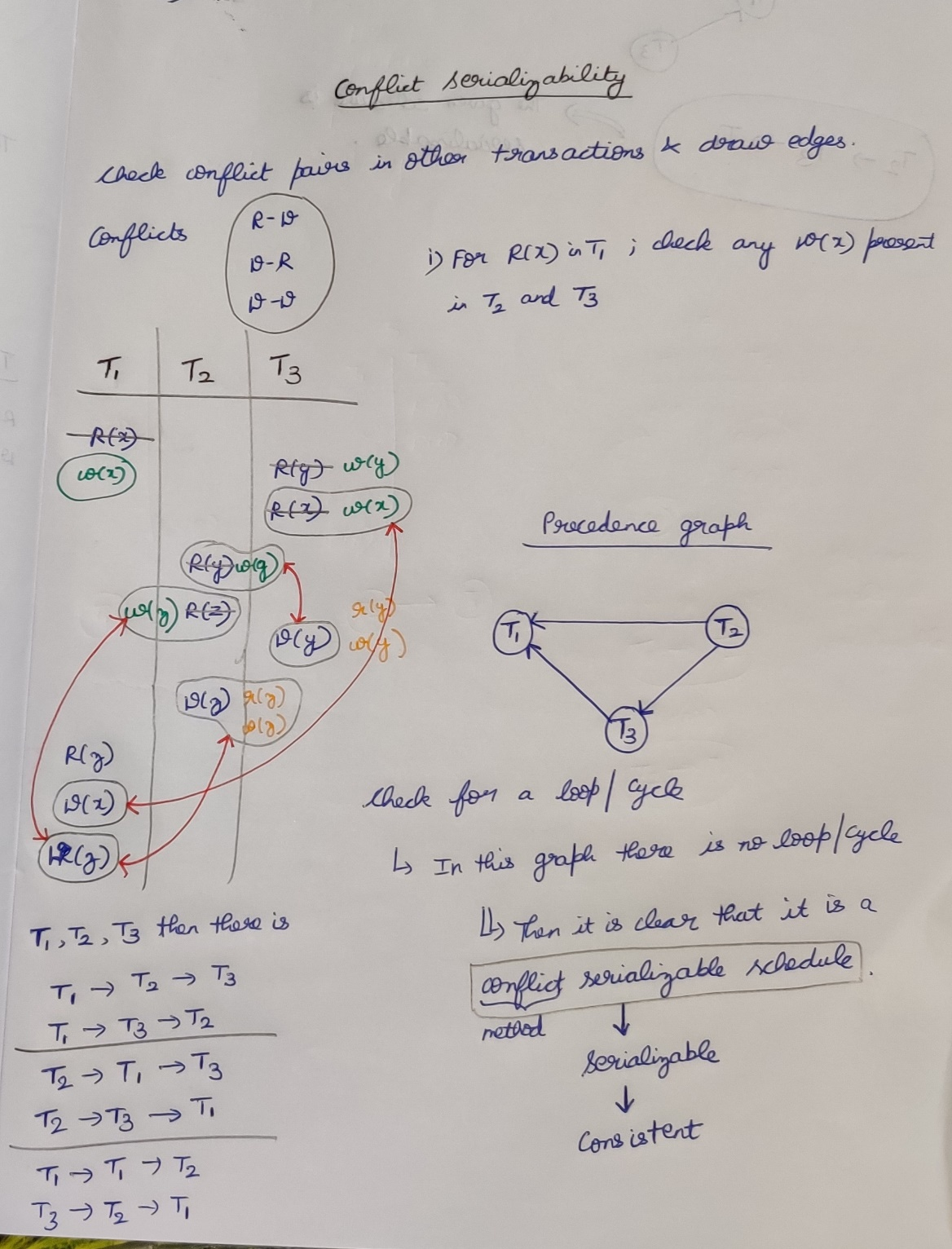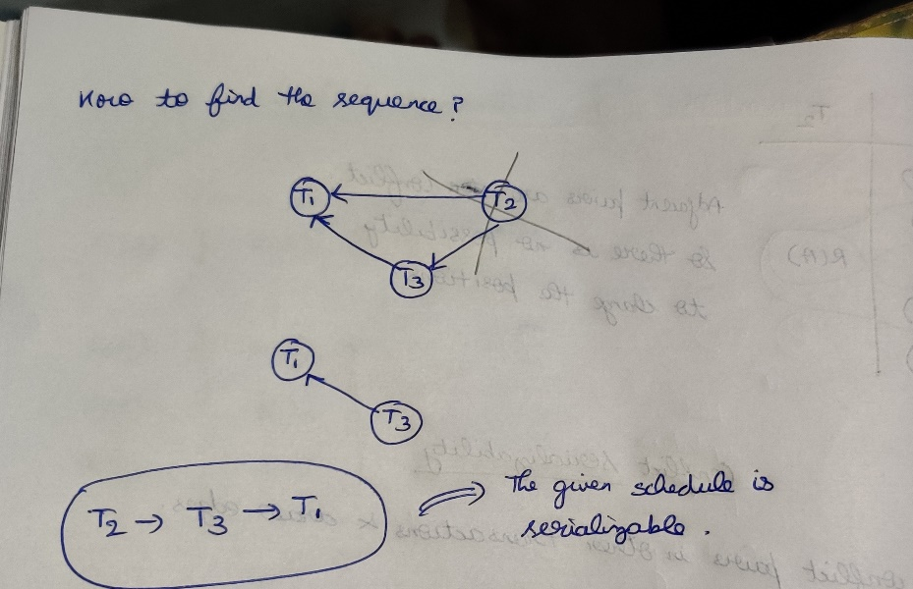

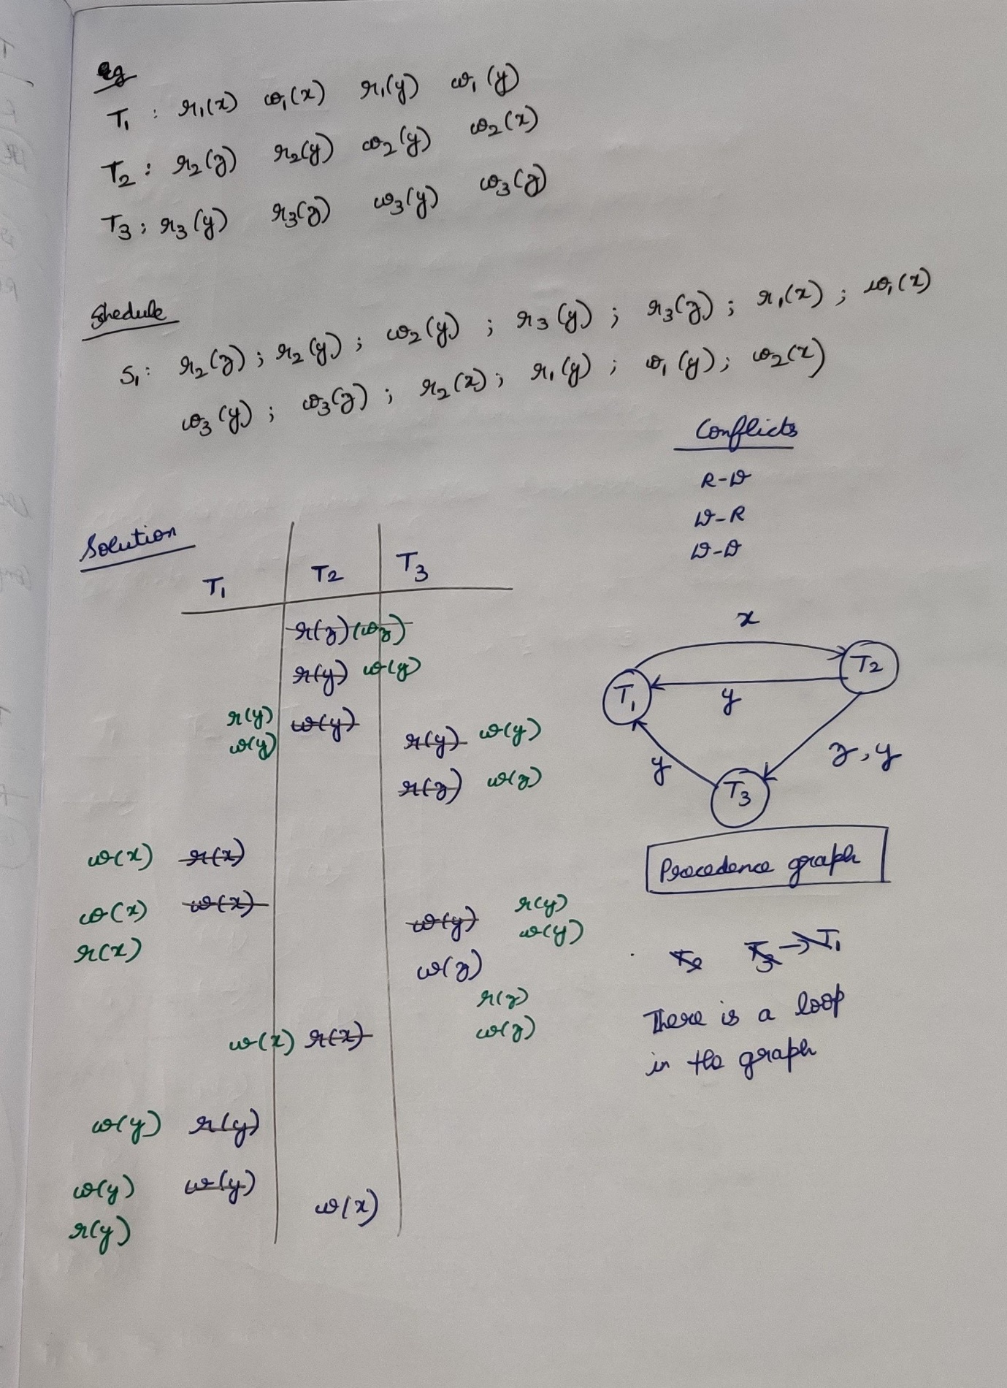

**View serializability**

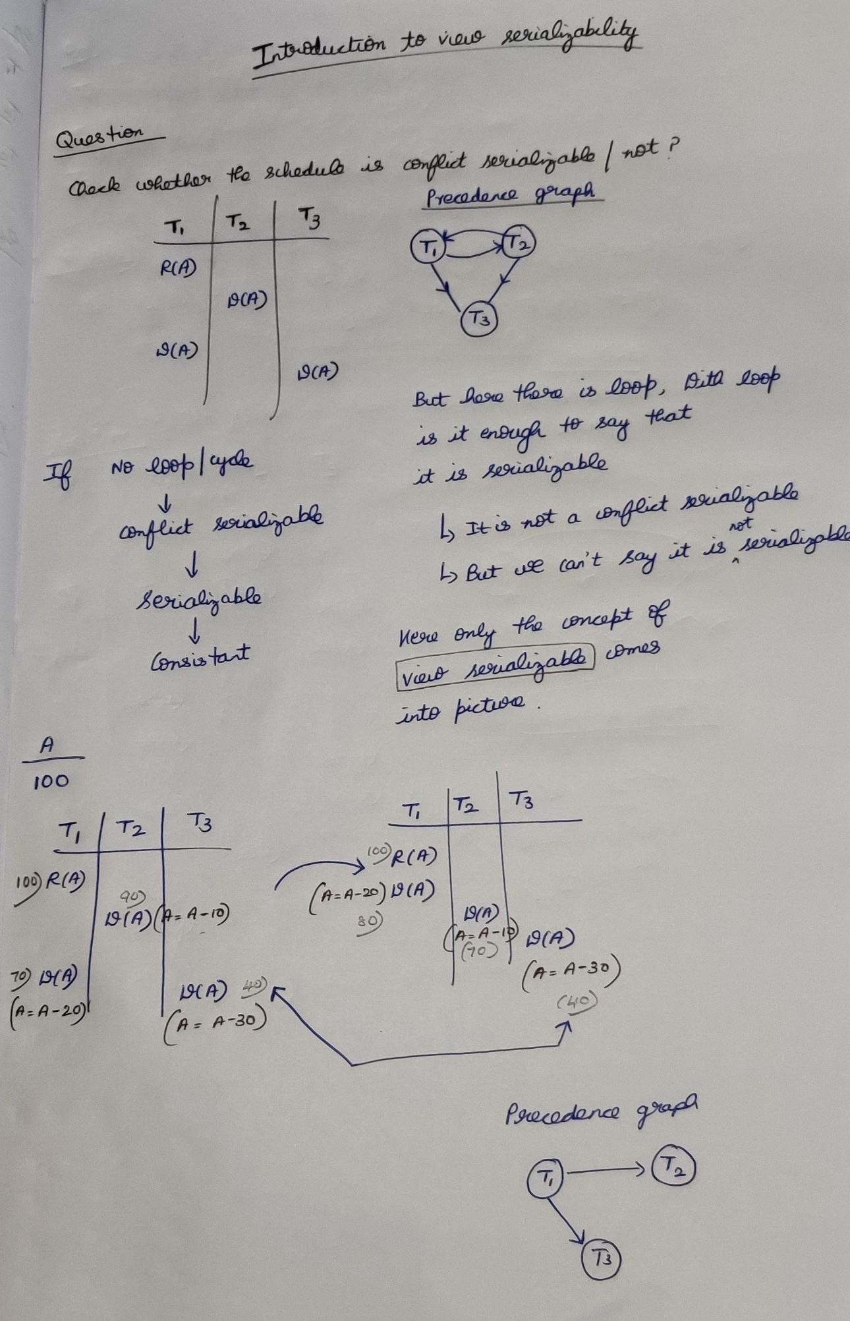

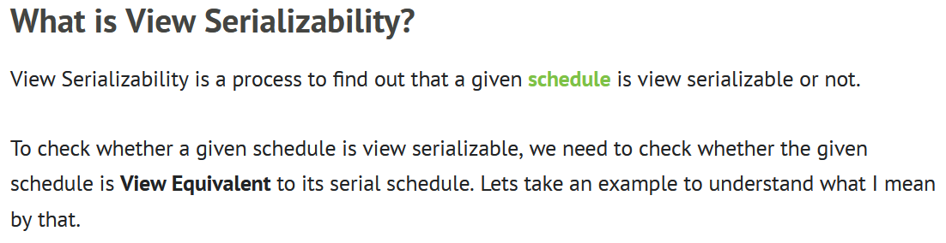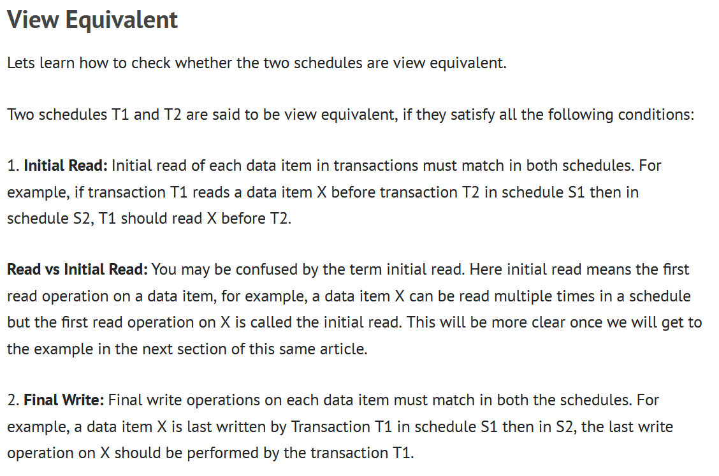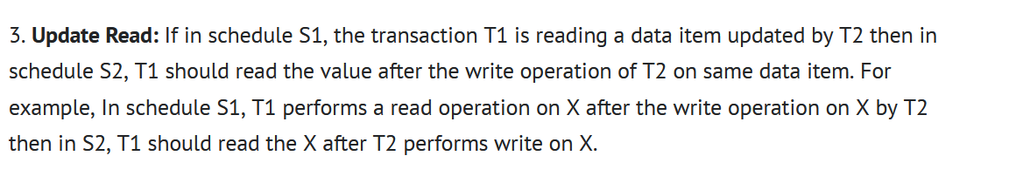



**Question**

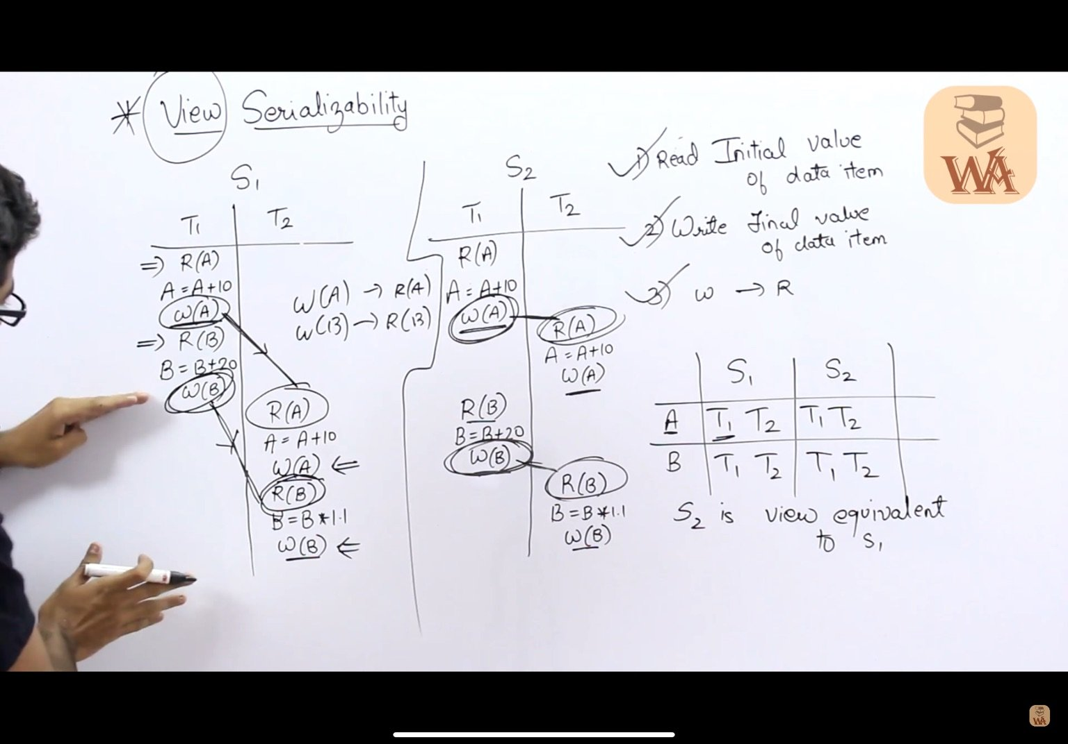

**Question**

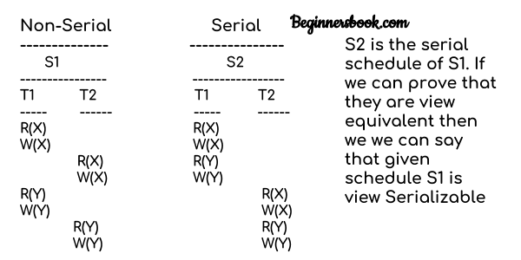



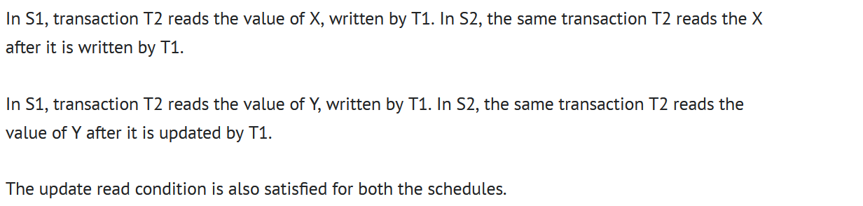

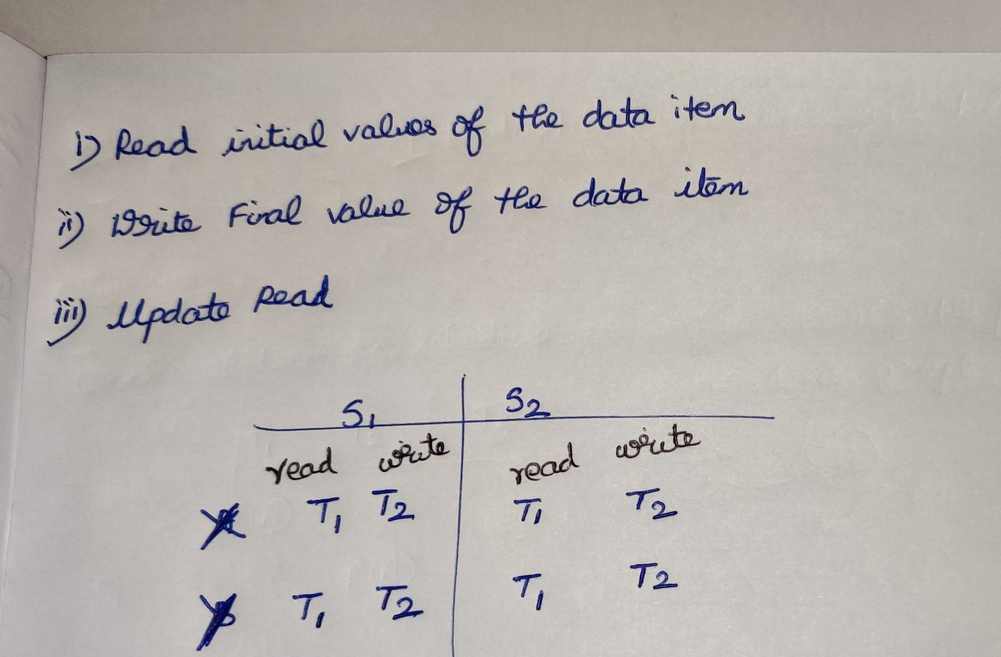

S1 is view equivalent to S2